ISO 20022

Market Claims

Message Definition Report Part 1

Maintenance 2020/2021 - Approved by ISO Securities SEG on the 25th of January 2021

This document provides information about the use of the messages for market claims and includes, for example, business scenarios and messages flows.

February 2021

Table of Contents

Table of Contents 2

1 Introduction 4

1.1 Terms and Definitions 4

1.2 Abbreviations and Acronyms 4

1.3 Document Scope and Objectives 5

1.4 References 5

2 Scope and Functionality 6

2.1 Background 6

2.2 Scope 6

2.3 Groups of MessageDefinitions and Functionality 7

3 BusinessRoles and Participants 8

3.1 Participants and BusinessRoles Definitions 8

3.2 BusinessRoles and Participants Table 9

4 BusinessProcess Description 10

4.1 Scenario 1 – Account Servicer (CSD system) generates market claims 10

4.2 Scenario 2 – Bilateral input of market claim 13

5 Description of BusinessActivities 16

5.1 Advise Account Holders of Market Claim Transaction 16

5.2 Provide Status of Market Claim Transaction 17

5.3 Cancel Market Claim Transaction (by Account Holder) 18

5.4 Cancel Market Claim Transaction (by Account Servicer) 19

6 BusinessTransactions 20

6.1 Simple Scenario 20

6.2 Complex Scenario 20

7 Business Examples 23

7.1 MarketClaimCreation - seev.050.001.01 23

7.2 MarketClaimCancellationRequest - seev.051.001.01 26

7.3 MarketClaimStatusAdvice - seev.052.001.01 28

7.4 MarketClaimCancellationRequestStatusAdvice - seev.053.001.01 31

Revision Record 34

Preliminary Note

The Message Definition Report (MDR) is made of three parts:

MDR part 1

This describes the contextual background required to understand the functionality of the proposed message set. Part 1 is produced by the submitting organisation that developed or maintained the message set in line with an MDR Part 1 template provided by the ISO 20022 Registration Authority (RA) on [www.iso20022.org](http://www.iso20022.org/).

MDR part 2

This is the detailed description of each message definition of the message set. Part 2 is produced by the RA using the model developed by the submitting organisation.

MDR part 3

This is an extract of the ISO 20022 Business Model describing the business concepts used in the message set. Part 3 is an Excel document produced by the RA.

# Introduction

## Terms and Definitions

The following terms are reserved words defined in ISO 20022 Edition 2013 – Part1. When used in this document, the UpperCamelCase notation is followed.

|  |  |
| --- | --- |
| Term | Definition |
| BusinessRole | Functional role played by a business actor in a particular BusinessProcess or BusinessTransaction. |
| Participant | Involvement of a BusinessRole in a BusinessTransaction. |
| BusinessProcess | Definition of the business activities undertaken by BusinessRoles within a BusinessArea whereby each BusinessProcess fulfils one type of business activity and whereby a BusinessProcess may include and extend other BusinessProcesses. |
| BusinessTransaction | Particular solution that meets the communication requirements and the interaction requirements of a particular BusinessProcess and BusinessArea. |
| MessageDefinition | Formal description of the structure of a message instance. |

1. When a MessageDefinition or message identifier is specified, it should include the variant and version number. However, in this document (except in the business examples section, if present), variant and version numbers are not included. In order to know the correct variant and version number for a MessageDefinition, the related Message Definition Report Part 2 document should be consulted.

## Abbreviations and Acronyms

The following is a list of abbreviations and acronyms used in the document.

|  |  |
| --- | --- |
| Abbreviation/Acronyms | Definition |
| ACK | Acknowledgement |
| AML | Anti-Money Laundering |
| BIC | Business Identifier Code |
| CSD | Central Securities Depository |
| CUG | Closed User Group |
| IBAN | International Bank Account Number |
| ICSD | International Central Securities Depository |
| KYC | Know Your Customer |
| MCR | Message Change Request |
| MDR | Message Definition Report |
| NAK | Negative acknowledge (reject) |
| SEG | Standards Evaluation Group |
| SLA | Service Level Agreement |
| SMPG | Securities Market Practice Group (www.smpg.info) |
| XML | eXtensible Mark-up Language |

## Document Scope and Objectives

This document is the first part of the Market Claims Message Definition Report (MDR) that describes the BusinessTransactions and underlying message set. For the sake of completeness, the document may also describe BusinessActivities that are not in the scope of the business processes covered in this document.

This document describes the following:

* the BusinessProcess scope
* the BusinessRoles involved in these BusinessProcesses

The main objectives of this document are as follows:

* to provide information about the messages that support the business processes
* to explain the BusinessProcesses and BusinessActivities these messages have addressed
* to give a high level description of BusinessProcesses and the associated BusinessRoles
* to document the BusinessTransactions
* to provide business examples

The messages definitions are specified in the Market Claims Message Definition Report Part 2.

## References

|  |  |  |  |
| --- | --- | --- | --- |
| Document | Version | Date | Author |
| ISO 20022 Business Justification - Market Claims (BJ 163) |  | 2020-07-17 | SMPG & SWIFT |

# Scope and Functionality

## Background

This Message Definition Report covers a set of four ISO 20022 message definitions developed by SWIFT and the SMPG to provide a communication solution to support the business processes and activities required for market claims.

## Scope

The business context is in accordance with the European standards for transaction management as per the Corporate Actions Joint Working Group (CAJWG) and T2S Corporate Actions Sub-Group (T2S CASG). The term market claims in this document and messages thus refers to a transaction/process to move the proceeds from a mandatory corporate action distribution event, from the party that received the proceeds to the party that was contractually entitled to receive the proceeds. Such a market claim is always related to a settlement transaction, and exists in two versions:

* a settlement transaction fails to settle as bilaterally agreed on or before record date, and hence a market claim is created to move the proceeds from the delivering party in the settlement transaction to the receiving party (commonly referred to as a market claim); or
* a settlement transaction settles on or before record date though it was bilaterally agreed to not include the right to receive the proceeds, and hence a market claim is created to move the proceeds from the receiving party in the settlement transaction to the delivering party (commonly referred to as a reverse market claim).

The scope of the ISO 20022 Market Claim messages is to instruct a new or replacement market claim, request cancellation of an existing market claim, and possibly also split/update an existing market claim. The two parties involved in the communication is an account servicer and an account holder.

Based on the European standards, Target2-Securities (T2S) functionality and the upcoming CSDR settlement discipline regime, the SMPG Corporate Actions (CA) Working Group (WG) has identified the below business needs:

* to report that a market claim has been generated and registered on the account holder's account, including both the market claim transaction details as well as the key CA event details (at least event reference, type, underlying ISIN) for cash and/or securities distribution;
* to report a status change of the market claim;
* to report the cancellation of a market claim;
* to request the cancellation of a market claim;
* to instruct a new or replacement market claim;
* to release a market claim for settlement and amend its priority – (already covered by the sese.030).

According to the European standards for transaction management as per the Corporate Actions Joint Working Group (CAJWG) and T2S Corporate Actions Sub-Group (T2S CASG), CSDs and CCPs are to generate market claims for affected settlement transactions, starting after close of business on record date and continuing for a period of 20 business days.

Market claims are to have an intended settlement date that is equal to the payment date of the CA event or the next business day, if the market claim is generated after payment date.

Market claims are to be created without any link to the underlying settlement transaction; the standards make it clear that a claim may indeed settle before the underlying settlement transaction. However, the CSD members may link a specific market claim to the underlying settlement transaction on a case-by-case basis. Market claims are to be generated with the same status as the underlying settlement instructions, i.e. if the delivery instruction was not released for settlement (likely due to a lack of securities), the market claim instruction will also be created without being released for settlement.

Before T2S, few CSDs supported functionality according to the above. Thus, there has been fairly little need in the industry for reporting of market claims generation and even less for status reporting between generation and settlement. With the T2S CASG standards, a number of European CSDs have implemented automated market claims functionality, but the lack of messages dedicated to purpose of informing about generation of market claims and the possibility for account servicers to control the settlement process of market claims remain un-addressed.

As market claims will not settle automatically in many situations and as they will be subject to CSDR penalties and buy-ins in case settlement does not take place, the impact of the CSDR settlement discipline regime on market claims may be severe.

## Groups of MessageDefinitions and Functionality

1. These messages are to be used with the ISO 20022 Business Application Header (head.001). The schema and more information about the Business Application Header (BAH) can be found on the www.iso20022.org web site

### Groups

The following tables show the message names, their mnemonic 4-characters abbreviated name and the message identifiers.

Two groups of flows can be distinguished:

#### Market Claim Creation and Status

|  |  |  |
| --- | --- | --- |
| MessageDefinition | Abbreviated Name | Message Identifier |
| MarketClaimCreation | MCCR | seev.050 |
| MarketClaimStatusAdvice | MCSA | seev.052 |

#### Market Claim Cancellation and Status

|  |  |  |
| --- | --- | --- |
| MessageDefinition | Abbreviated Name | Message Identifier |
| MarketClaimCancellationRequest | MCCN | seev.051 |
| MarketClaimCancellationRequestStatusAdvice | MCCS | seev.053 |

### Functionality

See Message Definition Report Part 2 for the message scopes and formats.

# BusinessRoles and Participants

A BusinessRole represents an entity (or a class of entities) of the real world, physical or legal, a person, a group of persons, a corporation. Examples of BusinessRoles: “Financial Institution”, “Automated Clearing House”, “Central Securities Depository”.

A Participant is a functional role performed by a BusinessRole in a particular BusinessProcess or BusinessTransaction. Examples of Participants: the “user” of a system, “debtor”, “creditor”, “investor”.

The relationship between BusinessRoles and Participants is many-to-many. One BusinessRole can be involved as different Participants at different moments in time or at the same time. Examples of BusinessRoles: "user", "debtor”, "creditor", "investor". Different BusinessRoles can be involved as the same Participant.

In the context of Shereholder Identification Disclosure, the high-level BusinessRoles and typical Participants are defined as follows:

## Participants and BusinessRoles Definitions

Participants

|  |  |
| --- | --- |
| Description | Definition |
| Account Servicer | The party providing a securities account for the Holder, as well as reporting the creation, settlement or cancellation of market claims. |
| Account Holder | The party holding a securities account with the Servicer, as well as instructing the cancellation or creation of market claims. |

Business Roles

|  |  |
| --- | --- |
| Description | Definition |
| Global Custodian | Party that safekeeps and administers assets on behalf of the owner and that has a network of sub-custodians. |
| Sub-Custodian | Party that safekeeps and administers assets on behalf of the owner |
| CSD | An infrastructure that, holds or controls, the holding of physical or dematerialised financial instruments belonging to all, or a large portion of, the investors in a securities market. This affects the centralised transfer of ownership of such securities by entries on its books and records. |
| ICSD | Holds or controls the holding of physical or dematerialised financial instruments belonging to all or a large portion of the investors in a securities market, and which effects the centralised transfer of such securities against payment (or free of payment) by entries on its books and records, resulting in transfer and record of ownership of the securities. A distinction can be made between a Central Securities Depository (CSD), which operates in a particular domestic market for specified financial instruments or an International Central Securities Depository (ICSD), that is, Euroclear and Clearstream, which settle Eurobond instruments and have direct or indirect links with specific CSDs owner (from Issuer (Agent). |

## BusinessRoles and Participants Table

|  |  |  |
| --- | --- | --- |
| Business Roles | Account Holder | **Account Servicer** |
| ICSD/CSD | X | X |
| Global / Sub Custodian | X | X |
| ICSD / CSD Particpants | X | X |

# BusinessProcess Description

This diagram represents the high level BusinessProcesses.

## Scenario 1 – Account Servicer (CSD system) generates market claims

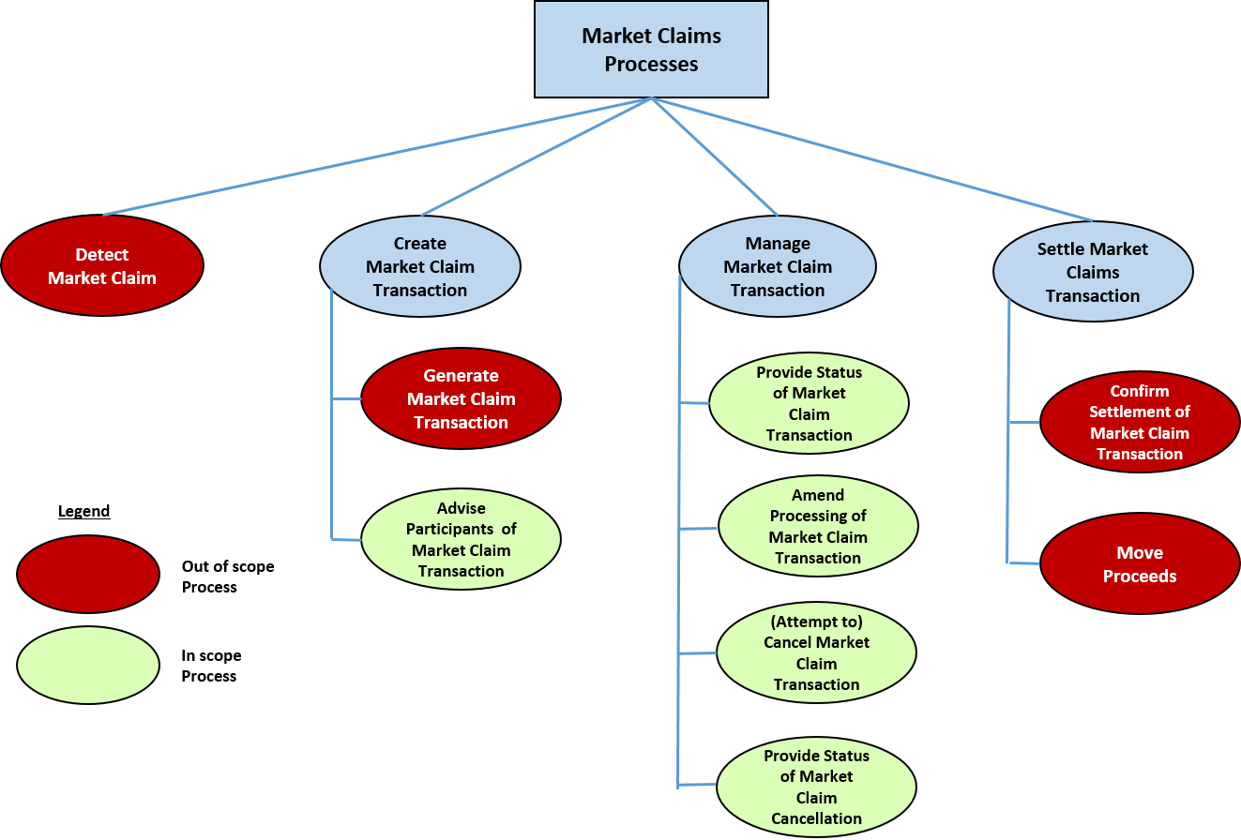

Advise Participants of Market Claim Transaction

|  |  |
| --- | --- |
| Item | Description |
| Definition | The process by which both participants/Account Holders to the underlying settlement transactions will be advised about the new Market Claim Transaction. Each Transaction will be communicated in a separate message. |
| Trigger: | After a market claim detection and a successful market claim transaction generation. |
| Pre-conditions | A failed securities settlement transaction affected by a mandatory corporate action distribution event. |
| Post-conditions | Both participants/Account Holders will have been sent a formatted message, one per each Market Claim Transaction, advising them of the transaction details. |
| Role | Account Servicer |

Provide Status of Market Claim Transaction

|  |  |
| --- | --- |
| Item | Description |
| Definition | The process by which the Account Servicer keeps the Market Claim Participants/Account Holders updated with changes in status of the Market Claim Transaction including status resulting from a failure to settle. |
| Trigger: | Any alteration in status for the Market Claim Transaction. |
| Pre-conditions | An un-cancelled, pending Market Claim Transaction. |
| Post-conditions | A communication to one, or both, Market Claim Participants/Account Holders advising of the current Status of the Market Claim transaction. |
| Role | Account Servicer |

Amend Processing of Market Claim Transaction

|  |  |
| --- | --- |
| Item | Description |
| Definition | The process by which the Market Claim Participant/s / Account Holder/-s can request the amendment of a Market Claim Transaction before it settles or is cancelled. This is performed via an MT530 or sese.030 message. |
| Trigger: | * the Market Claim Participant/Account Holder need to amend a Market Claim Transaction * the Market Claim Transaction needs to be transformed |
| Pre-conditions | An un-cancelled, pending Market Claim Transaction. |
| Post-conditions | A communication to the sender of the amendment request message and possibly also a separate communication to the counterparty providing the new status. |
| Role | * Account Holder * Account Servicer |

Cancel Market Claim Transaction

|  |  |
| --- | --- |
| Item | Description |
| Definition | The process by which the Market Claim Participant/s / Account Holder/-s can request the cancellation of a Market Claim Transaction before it settles or the Account Servicer removes the Market Claim Transaction from the Settlement system. |
| Trigger: | * the Market Claim Participant/Account Holder need to cancel a Market Claim Transaction * the Market Claim Transaction has been split * the Market Claim Transaction needs to be transformed |
| Pre-conditions | An un-cancelled, pending Market Claim Transaction. |
| Post-conditions | A communication to the sender of the Cancellation Request and a separate communication to the counterparty indicating that the Market Claim has been cancelled.  A fully cancelled Market Claim Transaction. |
| Role | * Account Holder * Account Servicer |

Provide Status of Market Claim Transaction Cancellation Request

|  |  |
| --- | --- |
| Item | Description |
| Definition | The process by which the Account Servicer keeps the Market Claim Participant/Account Holder updated with changes in status of the Market Claim Transaction Cancellation Request. |
| Trigger: | Receipt of a Market Claim Transactions Cancellation Request or alteration in status of a pending Market Claim Transaction Cancellation Request. |
| Pre-conditions | An un-cancelled, pending Market Claim Transaction. |
| Post-conditions | A communication to the sender of the Market Claim Cancellation Request advising of the Status of the Market Claim Transaction Cancellation Request. |
| Role | Account Servicer |

## Scenario 2 – Bilateral input of market claim

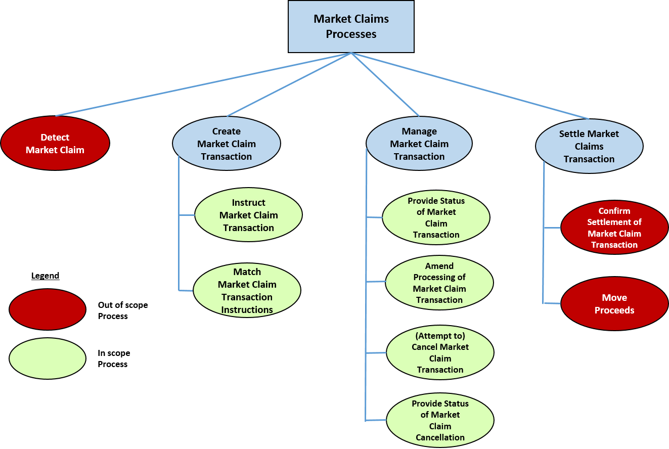

Bilateral instructions for a Market Claim Transaction

|  |  |
| --- | --- |
| Item | Description |
| Definition | The process by which both participants/Account Holders to the underlying settlement transaction will create and send instructions for a bilaterally instructed new Market Claim Transaction. Each Transaction will be communicated in a separate message. |
| Trigger: | After a market claim detection and bilateral agreement. |
| Pre-conditions | A failed securities settlement transaction affected by a mandatory corporate action distribution event, or a settled on record date though traded ex settlement transaction affected by a mandatory corporate action distribution event. |
| Post-conditions | Both participants/Account Holders have sent their agreed Market Claim Transaction instructions. |
| Role | * Account Holder |

Match Market Claim Transaction Instructions

|  |  |
| --- | --- |
| Item | Description |
| Definition | The process in which the Account Servicer matches the Market Claim settlement instructions. |
| Trigger: | A market claim settlement instruction has been received by the Account Servicer. |
| Pre-conditions | At least one participant/Account Holder has sent its agreed Market Claim Transaction instructions. |
| Post-conditions | Unmatched or matched status is reported. |
| Role | Account Servicer |

Provide Status of Market Claim Transaction

|  |  |
| --- | --- |
| Item | Description |
| Definition | The process by which the Account Servicer keeps the Market Claim Participants/Account Holders updated with changes in status of the Market Claim Transaction including status resulting from a failure to settle. |
| Trigger: | Any alteration in status for the Market Claim Transaction. |
| Pre-conditions | An instructed Market Claim Transaction. |
| Post-conditions | A communication to one, or both, Market Claim Participants/Account Holders advising of the current Status of the Market Claim transaction. |
| Role | Account Servicer |

Cancel Market Claim Transaction

|  |  |
| --- | --- |
| Item | Description |
| Definition | The process by which the Market Claim Participants/Account Holders can request the cancellation of a Market Claim Transaction before it settles or the Account Servicer removes the Market Claim Transaction from the Settlement system. |
| Trigger: | * the Market Claim Participant/Account Holder need to cancel a Market Claim Transaction * the Market Claim Transaction has been split * the Market Claim Transaction needs to be transformed |
| Pre-conditions | An un-cancelled, pending Market Claim Transaction. |
| Post-conditions | A communication to the sender of the Cancellation Request and a separate communication to the counterparty indicating that the Market Claim has been cancelled.  A fully cancelled Market Claim Transaction. |
| Role | * Account Holder * Account Servicer |

Amend Processing of Market Claim Transaction

|  |  |
| --- | --- |
| Item | Description |
| Definition | The process by which the Market Claim Participant/-s / Account Holder/-s can request the amendment of a Market Claim Transaction before it settles or is cancelled. This is performed via an MT530 or sese.030 message. |
| Trigger: | * the Market Claim Participant/Account Holder needs to amend a Market Claim Transaction * the Market Claim Transaction needs to be transformed |
| Pre-conditions | An un-cancelled, pending Market Claim Transaction. |
| Post-conditions | A communication to the sender of the amendment request message and possibly also a separate communication to the counterparty providing the new status. |
| Role | * Account Holder * Account Servicer |

Provide Status of Market Claim Transaction Cancellation Request

|  |  |
| --- | --- |
| Item | Description |
| Definition | The process by which the Account Servicer keeps the Market Claim Participant/Account Holder updated with changes in status of the Market Claim Transaction Cancellation Request. |
| Trigger: | Receipt of a Market Claim Transactions Cancellation Request or alteration in status of a pending Market Claim Transaction Cancellation Request. |
| Pre-conditions | An un-cancelled, pending Market Claim Transaction. |
| Post-conditions | A communication to the sender of the Market Claim Cancellation Request advising of the Status of the Market Claim Transaction Cancellation Request. |
| Role | Account Servicer |

# Description of BusinessActivities

This section presents the different BusinessActivities within each BusinessProcess. The BusinessActivities of a process are described with activity diagrams.

Legend

|  |  |  |
| --- | --- | --- |
| Symbol | Name | Definition |
|  | Start Point | Shows where the lifecycle of the business process commences. |
|  | End Point | Shows where the lifecycle of the business process may ends. |
|  | Lozenge (or diamond) | Indicates that a choice between several actions can be made. |
|  | Bar | Indicates that several actions are initiated in parallel. |

## Advise Account Holders of Market Claim Transaction



|  |  |  |
| --- | --- | --- |
| Step | Description | Initiator |
| Advise Account Holders of new market claim transaction | The market claim transaction is automatically generated by the Account Servicer and advise of this is sent to both market claim participants. | Account Servicer |

## Provide Status of Market Claim Transaction



Advise of a Changed status

|  |  |  |
| --- | --- | --- |
| Step | Description | Initiator |
| Advise Account Holders of market claim transaction status | A market claim status is communicated to the market claim participants/Account Holders each time the status of the claim is modified. | Account Servicer |

## Cancel Market Claim Transaction (by Account Holder)



|  |  |  |
| --- | --- | --- |
| Step | Description | Initiator |
| Request cancellation of market claim transaction | One the market claim participants/Account Holders submits a Cancellation Request to the Account Servicer. | Account Holder |
| Validate the market claim transaction cancellation request | The Account Servicer validates the cancellation request and either reject the cancellation request if the request is invalid by sending a cancellation request status, updates the market claim transaction cancellation request status to pending, or, if both Account Holders send cancellation requests, updates the status to cancelled. | Account Servicer |
| Advise Account Holder about market claim transaction status | Both the Account Holders are advised about the status of the market claim transaction i.e. either that cancellation of the market claim transaction is requested or that the marker claim transaction has been cancelled. | Account Servicer |

## Cancel Market Claim Transaction (by Account Servicer)



|  |  |  |
| --- | --- | --- |
| Step | Description | Initiator |
| Advise status of market claim transaction cancellation request | Under certain circumstances, the Account Servicer may be required to cancel a Market Claim before it settles or the Market Claim Transaction is cancelled due to reaching the maximum number of days allowed pending in the Settlement System.  The Account Holders are notified that the Market Claim Transaction has been cancelled. | Account Servicer |

# BusinessTransactions

This section describes the message flows based on the activity diagrams documented above. It illustrates the flows of the market claims messages in typical message sequencing scenarios. These messages are exchanged between an account servicer and an account holder.

## Simple Scenario

This scenario illustrates the communication flow between the instructing party and the executing/servicing party in a simple scenario where claims are generated and subsequently settled.



Account Servicer

Market Claim Creation - seev.050 (Generation of claim)

Corporate Action Confirmation - seev.036 (Confirm Settlement)

Account Holder

## Complex Scenario

This scenario illustrates the communication flow between the Account Holder and the Account Servicer in case of a complex scenario where:

A) claims are generated, the Account Holder requests a change in priority/hold & release and subsequently settled.



Account Servicer

Market Claim Creation - seev.050 (Generation of claim)

Corporate Action Confirmation – seev.036 (Confirm Settlement)

Account Holder

SecuritiesSettlementConditionsModificationRequest - sese.030 (Instruct priority change/hold & release)

Market Claim Status Advice – seev.052 (Report priority change/hold & release status)

Market Claim Status Advice – seev.052 (Change of Status)

message

B) claims are generated, the Account Holder requests a cancellation which is matched by the counterparty and the claim is fully cancelled.



Account Servicer

Market Claim Creation - seev.050 (Generation of claim)

Account Holder

MarketClaimCancellationRequest - seev.051

MarketClaimCancellationRequestStatusAdvice - seev.053

MarketClaimCancellationRequestStatusAdvice - seev.053

(Report change of claim status - fully cancelled)

C) claims are generated, the Account Holder requests a split (cancellation & new shapes) which is matched by the counterparty. The siblings settle on pay date.



Account Holder

Account Servicer

Market Claim Creation - seev.050 (Generation of claim)

Market Claim Cancellation Request - seev.051 (Instruct cancellation)

Market Claim Creation- seev.050 (Split part 1)

Market Claim Creation- seev.050 (split part 2)

Market Claim Cancellation Request Status Advice - seev.053 (report status Cancelled)

Market Claim Status Advice - seev.052

(report status Matched on split part 1)

Market Claim Status Advice - seev.052

(report status Matched on split part 2)

Report settlement of claims – seev.036 (Split Part 1)

Report settlement of claims – seev.036 (Split Part 2)

# Business Examples

This section describes business examples of the use of the MessageDefinitions, under scenario 1 (the Account Servicer/CSD system automatically detects and generates market claims).

## MarketClaimCreation - seev.050.001.01

**Example 1: Scenario Description**

A mandatory spin-off event with the below terms:

A mandatory spin-off at a rate of 1 additional share of FR0010193979 for each underlying share of FR0004548873. The record date is 18 May 20YY, the ex date is 17 May 20YY and the payment date is 19 May 20YY. The CSD/account servicer is CSDDFRPPXXX.

A pending/failing securities settlement transaction between CSD participant/account holder ABCDFRPPXXX and CSD participant/account holder EFGHFRPPXXX:

EFGHFRPPXXX, account EFefgh032, is to deliver 8,000 shares of FR0004548873 to ABCDFRPPXXX, account EFabcd001, against a settlement amount of EUR32,000. Trade date is 16 May 20YY and intended settlement date is 18 May 20YY. After end of settlement on 18 May 20YY, the transaction remains pending; neither partial nor full settlement has occurred.

The CSD system thus detects the need for a Market Claim Transaction and generates this market claim cretion message (as illustrated below) to transfer 8,000 shares of FR0010193979 from EFGHFRPPXXX, account EFefgh032, to ABCDFRPPXXX, account EFabcd001 with a pay date / intended settlement date of 19 May 20YY.

The message is sent from the CSD to the CSD participants ABCDFRPPXXX BIC address.

ABCDFRPPXXX's receive versus payment settlement instruction has a reference of abcd123. EFGHFRPPXXX's delivery versus payment settlement instruction on account has a reference of efgh789.

**Message Instance (with application header)**

<AppHdr xmlns="urn:iso:std:iso:20022:tech:xsd:head.001.001.02" xmlns:n1="http://www.w3.org/2000/09/xmldsig#">

<Fr>

<FIId>

<FinInstnId>

<BICFI>CSDDFRPPXXX</BICFI>

</FinInstnId>

</FIId>

</Fr>

<To>

<FIId>

<FinInstnId>

<BICFI>ABCDFRPPXXX</BICFI>

</FinInstnId>

</FIId>

</To>

<BizMsgIdr>CSDD000000001</BizMsgIdr>

<MsgDefIdr>seev.050.001.01</MsgDefIdr>

<CreDt>2020-05-18T16:30:00Z</CreDt>

</AppHdr>

<Document xmlns="urn:iso:std:iso:20022:tech:xsd:seev.050.001.01" xmlns:xsi="http://www.w3.org/2001/XMLSchema-instance">

<MktClmCre>

<TxRef>

<AcctSvcrTxId>ABCDEFGH123456789</AcctSvcrTxId>

<MktInfrstrctrTxId>MI123456789</MktInfrstrctrTxId>

</TxRef>

<CorpActnGnlInf>

<CorpActnEvtId>SOFF00000356456</CorpActnEvtId>

<OffclCorpActnEvtId>COAFSOFF123456789</OffclCorpActnEvtId>

<EvtTp>

<Cd>SOFF</Cd>

</EvtTp>

<FinInstrmId>

<ISIN>FR0004548873</ISIN>

</FinInstrmId>

</CorpActnGnlInf>

<RltdSttlmInstrDtls>

<RltdSttlmInstrId>efgh789</RltdSttlmInstrId>

<RltdSttlmQty>

<Unit>8000</Unit>

</RltdSttlmQty>

</RltdSttlmInstrDtls>

<AcctDtls>

<SfkpgAcct>EFefgh032</SfkpgAcct>

<AcctOwnr>

<AnyBIC>EFGHFRPPXXX</AnyBIC>

</AcctOwnr>

</AcctDtls>

<CorpActnDtls>

<RcrdDt>

<Dt>2020-05-18</Dt>

</RcrdDt>

<ExDvddDt>

<Dt>2020-05-17</Dt>

</ExDvddDt>

</CorpActnDtls>

<MktClmTp>MKTC</MktClmTp>

<MktClmDtls>

<OptnNb>001</OptnNb>

<OptnTp>

<Cd>SECU</Cd>

</OptnTp>

<SctiesMvmntDtls>

<FinInstrmId>

<ISIN>FR0010193979</ISIN>

</FinInstrmId>

<CdtDbtInd>CRDT</CdtDbtInd>

<EntitldQty>

<Qty>

<Unit>8000</Unit>

</Qty>

</EntitldQty>

<PmtDt>

<DtOrDtTm>

<Dt>2020-05-19</Dt>

</DtOrDtTm>

</PmtDt>

</SctiesMvmntDtls>

</MktClmDtls>

</MktClmCre>

</Document>

## MarketClaimCancellationRequest - seev.051.001.01

**Example 1: Scenario Description**

CSD participant/account holder ABCDFRPPXXX would like to cancel the market claim that has been created by CSD/account servicer CSDDFRPPXXX, and sends a cancellation request for the market claim ABCDEFGH123456789.

**Message Instance (with application header)**

<AppHdr xmlns="urn:iso:std:iso:20022:tech:xsd:head.001.001.02" xmlns:n1="http://www.w3.org/2000/09/xmldsig#">

<Fr>

<FIId>

<FinInstnId>

<BICFI>ABCDFRPPXXX</BICFI>

</FinInstnId>

</FIId>

</Fr>

<To>

<FIId>

<FinInstnId>

<BICFI>CSDDFRPPXXX</BICFI>

</FinInstnId>

</FIId>

</To>

<BizMsgIdr>ABCDFRPP000000002</BizMsgIdr>

<MsgDefIdr>seev.051.001.01</MsgDefIdr>

<CreDt>2020-05-19T08:00:00Z</CreDt>

</AppHdr>

<Document xmlns="urn:iso:std:iso:20022:tech:xsd:seev.051.001.01" xmlns:xsi="http://www.w3.org/2001/XMLSchema-instance">

<MktClmCxlReq>

<MktClmCreId>

<Id>CSDD000000001</Id>

</MktClmCreId>

<TxRef>

<AcctSvcrTxId>ABCDEFGH123456789</AcctSvcrTxId>

<MktInfrstrctrTxId>MI123456789</MktInfrstrctrTxId>

</TxRef>

<CorpActnGnlInf>

<CorpActnEvtId>SOFF00000356456</CorpActnEvtId>

<OffclCorpActnEvtId>COAFSOFF123456789</OffclCorpActnEvtId>

<EvtTp>

<Cd>SOFF</Cd>

</EvtTp>

<FinInstrmId>

<ISIN>FR0004548873</ISIN>

</FinInstrmId>

</CorpActnGnlInf>

<AcctDtls>

<SfkpgAcct>EFefgh032</SfkpgAcct>

<AcctOwnr>

<AnyBIC>EFGHFRPPXXX</AnyBIC>

</AcctOwnr>

</AcctDtls>

</MktClmCxlReq>

</Document>

## MarketClaimStatusAdvice - seev.052.001.01

**Example 1: Scenario Description**

CSD/account servicer CSDDFRPPXXX sends a status advice to CSD participant/account holder EFGHFRPPXXX to inform of the cancellation request from ABCDFRPPXXX for the market claim ABCDEFGH123456789.

**Message Instance (with application header)**

<AppHdr xmlns="urn:iso:std:iso:20022:tech:xsd:head.001.001.02" xmlns:n1="http://www.w3.org/2000/09/xmldsig#">

<Fr>

<FIId>

<FinInstnId>

<BICFI>CSDDFRPPXXX</BICFI>

</FinInstnId>

</FIId>

</Fr>

<To>

<FIId>

<FinInstnId>

<BICFI>EFGHFRPPXXX</BICFI>

</FinInstnId>

</FIId>

</To>

<BizMsgIdr>CSDD0000000011</BizMsgIdr>

<MsgDefIdr>seev.052.001.01</MsgDefIdr>

<CreDt>2020-05-19T08:01:00Z</CreDt>

</AppHdr>

<Document xmlns="urn:iso:std:iso:20022:tech:xsd:seev.052.001.01" xmlns:xsi="http://www.w3.org/2001/XMLSchema-instance">

<MktClmStsAdvc>

<MktClmCreId>

<Id>CSDD000000001</Id>

</MktClmCreId>

<TxRef>

<AcctSvcrTxId>ABCDEFGH123456789</AcctSvcrTxId>

<MktInfrstrctrTxId>MI123456789</MktInfrstrctrTxId>

</TxRef>

<CorpActnGnlInf>

<CorpActnEvtId>SOFF00000356456</CorpActnEvtId>

<OffclCorpActnEvtId>COAFSOFF123456789</OffclCorpActnEvtId>

<EvtTp>

<Cd>SOFF</Cd>

</EvtTp>

<FinInstrmId>

<ISIN>FR0004548873</ISIN>

</FinInstrmId>

</CorpActnGnlInf>

<AcctDtls>

<SfkpgAcct>EFefgh032</SfkpgAcct>

<AcctOwnr>

<AnyBIC>EFGHFRPPXXX</AnyBIC>

</AcctOwnr>

</AcctDtls>

<MktClmPrcgSts>

<Pdg>

<Rsn>

<RsnCd>

<Cd>OTHR</Cd>

</RsnCd>

<AddtlRsnInf>COUNTERPARTY HAS REQUESTED CANCELLATION</AddtlRsnInf>

</Rsn>

</Pdg>

</MktClmPrcgSts>

<MktClmDtls>

<OptnNb>001</OptnNb>

<OptnTp>

<Cd>SECU</Cd>

</OptnTp>

<SctiesMvmntDtls>

<FinInstrmId>

<ISIN>FR0010193979</ISIN>

</FinInstrmId>

<CdtDbtInd>DBIT</CdtDbtInd>

<EntitldQty>

<Qty>

<Unit>8000</Unit>

</Qty>

</EntitldQty>

<PmtDt>

<DtOrDtTm>

<Dt>2020-05-19</Dt>

</DtOrDtTm>

</PmtDt>

</SctiesMvmntDtls>

</MktClmDtls>

</MktClmStsAdvc>

</Document>

## MarketClaimCancellationRequestStatusAdvice - seev.053.001.01

**Example 1: Scenario Description**

CSD/account servicer CSDDFRPPXXX sends a status advice to CSD participant/account holder ABCDFRPPXXX to confirm cancellation of the market claim ABCDEFGH123456789.

**Message Instance (with application header)**

<AppHdr xmlns="urn:iso:std:iso:20022:tech:xsd:head.001.001.02" xmlns:n1="http://www.w3.org/2000/09/xmldsig#">

<Fr>

<FIId>

<FinInstnId>

<BICFI>CSDDFRPPXXX</BICFI>

</FinInstnId>

</FIId>

</Fr>

<To>

<FIId>

<FinInstnId>

<BICFI>ABCDFRPPXXX</BICFI>

</FinInstnId>

</FIId>

</To>

<BizMsgIdr>CSDD0000000017</BizMsgIdr>

<MsgDefIdr>seev.053.001.01</MsgDefIdr>

<CreDt>2020-05-19T08:15:30Z</CreDt>

</AppHdr>

<Document xmlns="urn:iso:std:iso:20022:tech:xsd:seev.053.001.01" xmlns:xsi="http://www.w3.org/2001/XMLSchema-instance">

<MktClmCxlReqStsAdvc>

<MktClmCxlReqId>

<Id>ABCDFRPP000000002</Id>

</MktClmCxlReqId>

<TxRef>

<AcctSvcrTxId>ABCDEFGH123456789</AcctSvcrTxId>

<MktInfrstrctrTxId>MI123456789</MktInfrstrctrTxId>

</TxRef>

<CorpActnGnlInf>

<CorpActnEvtId>SOFF00000356456</CorpActnEvtId>

<OffclCorpActnEvtId>COAFSOFF123456789</OffclCorpActnEvtId>

<EvtTp>

<Cd>SOFF</Cd>

</EvtTp>

<FinInstrmId>

<ISIN>FR0004548873</ISIN>

</FinInstrmId>

</CorpActnGnlInf>

<MktClmCxlReqSts>

<CxlCmpltd>

<Rsn>

<RsnCd>

<Cd>CANI</Cd>

</RsnCd>

</Rsn>

</CxlCmpltd>

</MktClmCxlReqSts>

<MktClmDtls>

<OptnNb>001</OptnNb>

<OptnTp>

<Cd>SECU</Cd>

</OptnTp>

<SctiesMvmntDtls>

<FinInstrmId>

<ISIN>FR0010193979</ISIN>

</FinInstrmId>

<CdtDbtInd>CRDT</CdtDbtInd>

<EntitldQty>

<Qty>

<Unit>8000</Unit>

</Qty>

</EntitldQty>

<PmtDt>

<DtOrDtTm>

<Dt>2020-05-19</Dt>

</DtOrDtTm>

</PmtDt>

</SctiesMvmntDtls>

</MktClmDtls>

</MktClmCxlReqStsAdvc>

</Document>

# Revision Record

|  |  |  |  |  |
| --- | --- | --- | --- | --- |
| Revision | Date | Author | Description | Section Affected |
| 1.0 | 1 Dec 2020 | SWIFT | Edition for SEG review | All |
| 2.0 | February 2021 | ISO 20022 RA | Editing before publishing | NA |

Disclaimer

Although the Registration Authority has used all reasonable efforts to ensure accuracy of the contents of the iso20022.org website and the information published thereon, the Registration Authority assumes no liability whatsoever for any inadvertent errors or omissions that may appear thereon. Moreover, the information is provided on an "as is" basis. The Registration Authority disclaims all warranties and conditions, either express or implied, including but not limited to implied warranties of merchantability, title, non-infringement and fitness for a particular purpose.

The Registration Authority shall not be liable for any direct, indirect, special or consequential damages arising out of the use of the information published on the iso20022.org website, even if the Registration Authority has been advised of the possibility of such damages.

Intellectual Property Rights

The (candidate) ISO 20022 MessageDefinitions described in this document were contributed by SWIFT. The ISO 20022 IPR policy is available at www.ISO20022.org > About ISO 20022 > Intellectual Property Rights.